**Personal finance management system**

Submitted by

**K. Pavan (192210543)**

**K. Vijay Kumar (192211884)**

**G. Chandra Sekhar (192211135)**

**B. Manohar (192211557)**

**A. Parthasarathy (192211244)**

Guided by

**JayaSudha**

Course Faculty

**Department of Computer Science and**

**Engineering,**

**Saveetha School of Engineering, SIMATS**

**Thandalam, Chennai**

# PROBLEMSTATEMENT

"In today's dynamic financial landscape, individuals often struggle with organizing and optimizing their personal finances. Without a comprehensive tool, many face challenges in budgeting effectively, tracking expenses accurately, planning for future goals, and achieving financial security. There is a pressing need for a robust personal finance management system that simplifies financial decision-making, provides real-time insights, promotes smart money management practices, and empowers users to achieve their financial objectives efficiently."

# INTRODUCTION

In today's fast-paced world, where financial decisions can significantly impact one's quality of life, the ability to manage personal finances effectively has become a cornerstone of modern living. However, many individuals find themselves overwhelmed by the complexities of financial planning, budgeting, and investment. Without a structured approach and the right tools, navigating these challenges can seem daunting and often leads to missed opportunities or financial setbacks.

Moreover, the digital age has ushered in unprecedented levels of convenience and complexity in managing finances. While numerous apps and services promise to simplify money management, the sheer variety and fragmentation of available tools can confuse rather than empower users. This landscape underscores a critical need for a unified, intuitive, and robust personal finance management system.

Such a system would not only consolidate financial data but also provide actionable insights into spending patterns, savings opportunities, and investment strategies. By leveraging technology to automate routine financial tasks and enhance financial literacy, this system can empower individuals to take control of their financial futures proactively.

# DATASETANALYSIS

## Step 1: Collecting the Data

* • Sources**:** Collect transactional data from users' bank accounts, credit cards, or manual inputs from budgeting apps.
* • Variables**:** Capture variables such as income, expenses, savings, investments, debt, and financial goals.
* **3. Data Cleaning and Preprocessing**
* **Handle Missing Data:** Impute missing values or exclude incomplete records.
* **Normalize Data:** Standardize numerical variables for consistency.
* **Remove Outliers:** Exclude data points that significantly deviate from the norm if necessary.
* **4. Exploratory Data Analysis (EDA)**
* **Descriptive Statistics:** Compute key metrics (e.g., average monthly spending, savings rate).
* **Data Visualization:** Create visualizations (bar charts, histograms) to explore distributions and relationships.
* **Segmentation:** Group users based on demographics or financial behaviors.
* **5. Data Analysis**
* **Pattern Recognition:** Identify trends in spending habits, savings behavior, or investment preferences.
* **Correlation Analysis:** Determine relationships between variables (e.g., income vs. savings rate).
* **Prediction Modelling:** Use regression or machine learning algorithms to predict future financial behaviours.
* **6. Interpretation and Insight Generation**
* **Insights:** Extract insights like common spending categories, optimal savings strategies, or predictors of financial stress.
* **Recommendations:** Provide personalized recommendations for budgeting, saving goals, or investment diversification.
* **7. Reporting and Visualization**
* **Summarize Findings:** Present findings in reports or dashboards tailored for users and stakeholders.
* **Visual Representation:** Use charts and graphs to convey insights effectively.

# ENVIRONMENTALSETUP

**1. Hardware and Infrastructure**

* **Server or Cloud Hosting:** Decide whether to host the system on-premises or in the cloud (e.g., AWS, Azure, Google Cloud).
* **Database:** Choose a database management system (e.g., MySQL, PostgreSQL) to store financial data securely.
* **Backup and Recovery:** Implement backup procedures to prevent data loss and ensure business continuity.
* **Scalability:** Design the infrastructure to accommodate growth and increased usage over time.

**2. Software Components**

* **Application Development:** Develop or select a personal finance management software application tailored to user needs (e.g., budgeting, expense tracking, investment management).
* **Security Measures:** Implement robust security protocols (e.g., encryption, authentication) to protect sensitive financial information.
* **Integration:** Integrate with financial institutions’ APIs for real-time transaction updates and account aggregation.
* **User Interface:** Design an intuitive user interface (UI) and user experience (UX) to facilitate easy navigation and data input.

**3. Data Management and Compliance**

* **Data Privacy:** Adhere to data protection regulations (e.g., GDPR, CCPA) to safeguard user privacy and financial data.
* **Data Quality:** Ensure data accuracy and consistency through validation and cleaning processes.
* **Audit Trails:** Maintain audit trails to track changes and ensure transparency in financial transactions.

**4. Functional Features**

* **Budgeting Tools:** Provide tools for creating and managing budgets, setting financial goals, and tracking progress.
* **Expense Tracking:** Enable users to categorize and monitor expenses across different accounts and categories.
* **Investment Management:** Offer features for portfolio tracking, investment analysis, and retirement planning.
* **Alerts and Notifications:** Implement alerts for budget limits, upcoming bills, and unusual spending patterns.

**5. User Support and Education**

* **Help Desk:** Set up a support system to assist users with technical issues and system inquiries.
* **Financial Education:** Provide resources, tips, and tutorials to enhance users’ financial literacy and maximize the system’s benefits.

**6. Testing and Deployment**

* **Testing:** Conduct rigorous testing (e.g., unit testing, integration testing) to ensure functionality, security, and performance.
* **Deployment Strategy:** Plan a phased deployment to minimize disruptions and ensure a smooth transition for users.

**7. Monitoring and Maintenance**

* **Performance Monitoring:** Monitor system performance and user activity to identify issues and optimize performance.
* **Regular Updates:** Schedule regular updates and patches to fix bugs, enhance security, and introduce new features.
* **Feedback Mechanism:** Gather user feedback to continuously improve the system based on user needs and preferences.

**DATA FLOW DIAGRAM**

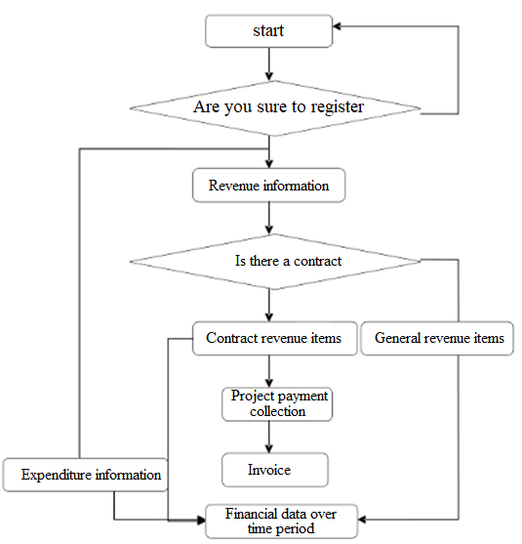

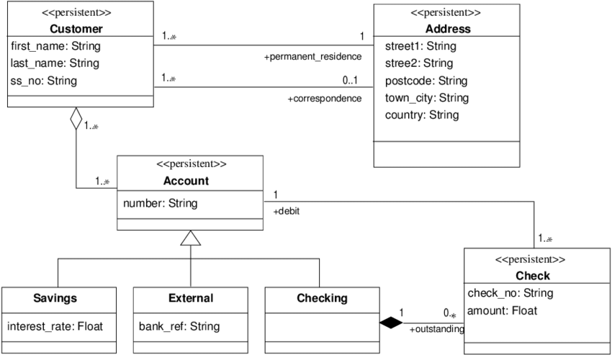 **CODESKELETON**

class User:

def __init__(self, username, password):

self.username = username

self.password = password

self.budgets = {}

self.expenses = []

def add_budget(self, category, amount):

self.budgets[category] = amount

def add_expense(self, category, amount, description):

self.expenses.append({"category": category, "amount": amount, "description": description})

def view_budgets(self):

print("Budgets:")

for category, amount in self.budgets.items():

print(f"{category}: ${amount}")

def view_expenses(self):

print("Expenses:")

for expense in self.expenses:

print(f"{expense['category']}: ${expense['amount']} - {expense['description']}")

class PersonalFinanceSystem:

def __init__(self):

self.users = {}

def register_user(self, username, password):

if username in self.users:

print("Username already exists. Please choose another.")

else:

self.users[username] = User(username, password)

print("User registered successfully.")

def login_user(self, username, password):

if username in self.users and self.users[username].password == password:

print(f"Welcome, {username}!")

return self.users[username]

else:

print("Invalid username or password.")

return None

def main_menu(self):

print("Welcome to Personal Finance Management System")

while True:

print("\nMenu:")

print("1. Register")

print("2. Login")

print("3. Exit")

choice = input("Enter your choice: ")

if choice == "1":

username = input("Enter username: ")

password = input("Enter password: ")

self.register_user(username, password)

elif choice == "2":

username = input("Enter username: ")

password = input("Enter password: ")

user = self.login_user(username, password)

if user:

self.user_menu(user)

elif choice == "3":

print("Exiting...")

break

else:

print("Invalid choice. Please try again.")

def user_menu(self, user):

while True:

print("\nUser Menu:")

print("1. Add Budget")

print("2. Add Expense")

print("3. View Budgets")

print("4. View Expenses")

print("5. Logout")

choice = input("Enter your choice: ")

if choice == "1":

category = input("Enter budget category: ")

amount = float(input("Enter budget amount: "))

user.add_budget(category, amount)

elif choice == "2":

category = input("Enter expense category: ")

amount = float(input("Enter expense amount: "))

description = input("Enter expense description: ")

user.add_expense(category, amount, description)

elif choice == "3":

user.view_budgets()

elif choice == "4":

user.view_expenses()

elif choice == "5":

print("Logging out...")

break

else:

print("Invalid choice. Please try again.")

# Main program entry point

if __name__ == "__main__":

pfm_system = PersonalFinanceSystem()

pfm_system.main_menu()

# RESULT ANALYSIS

**1. Data Collection and Preparation**

* **Data Sources:** Gather user-input financial data (e.g., income, expenses, savings goals) and transactional data (e.g., bank statements, credit card transactions).
* **Data Cleaning:** Remove duplicates, handle missing values, and ensure data consistency.

**2. Key Metrics and Analysis**

* **Budget Adherence:** Evaluate how well users stick to their budget limits across different categories (e.g., food, entertainment).
* **Spending Patterns:** Analyze trends in spending behavior over time and by category to identify areas of overspending or potential savings.
* **Savings Rate:** Calculate the percentage of income saved by users to assess financial health and savings habits.
* **Debt Management:** Monitor debt levels and repayment strategies to gauge progress towards financial goals.

**3. Segmentation and Comparison**

* **User Segmentation:** Group users based on demographics (e.g., age, income level) or financial behaviors (e.g., conservative vs. aggressive investors) for targeted analysis.
* **Benchmarking:** Compare individual user metrics against industry benchmarks or peer groups to provide context and actionable insights.

**4. Visualization and Reporting**

* **Charts and Graphs:** Use visualizations (e.g., bar charts, line graphs) to present trends, comparisons, and distributions effectively.
* **Reports:** Compile detailed reports summarizing key findings, trends, and recommendations for users to review and act upon.

**5. Insights and Recommendations**

* **Identify Opportunities:** Highlight areas where users can improve financial management (e.g., reduce discretionary spending, increase savings rate).
* **Goal Setting:** Provide recommendations for setting and achieving financial goals (e.g., retirement planning, emergency savings).
* **Behavioral Insights:** Offer behavioral nudges or tips based on user data to promote positive financial habits.

**6. Feedback and Iteration**

* **User Feedback:** Gather feedback from users on the effectiveness of insights and recommendations provided.
* **Continuous Improvement:** Iterate on analysis methods and system features based on user feedback and evolving financial trends.

# OUTPUTSAMPLES

